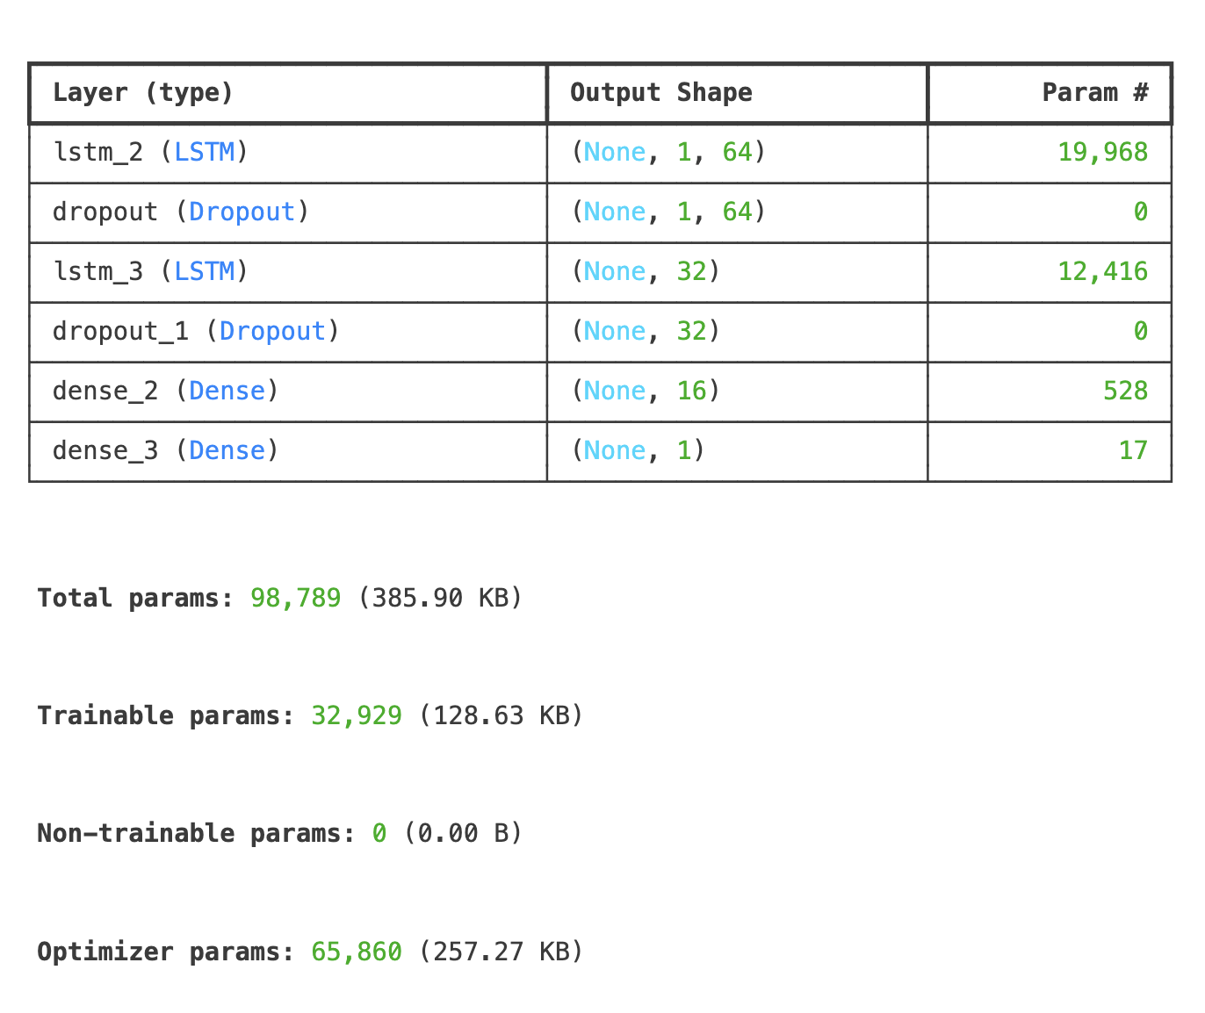

Number of epochs ran: 5

Batch size used: 64

Optimizer used: Adam

A model made without feature engineering, for testing the dataset. Got the highest accuracy of 50% on the validation dataset. Model type: LSTM